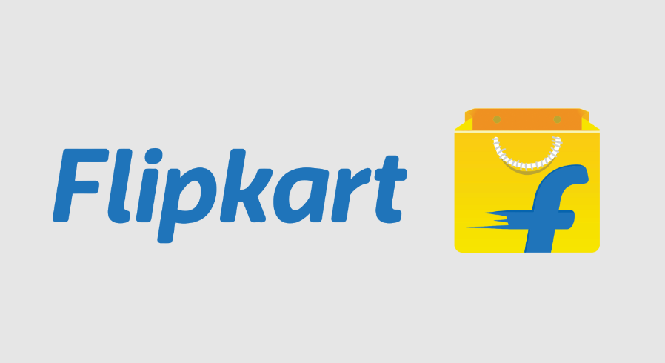

**Product Dissection for Flipcart**

### **Company Overview:**

Flipcart was founded in october 2007 by sachin bansal and binny bansal ,they were amazon employees . This platform works the same as amazon because the basic idea of creating this is amazon behind this .Flipkart invested heavily in its technology and logistics infrastructure. Basically it works as a third party reference . It launched features like "Flipkart First," a loyalty program, and introduced a mobile app to enhance customer experience.Flipkart introduced its annual "Big Billion Day" sale in 2014, which became one of the largest online sales events in India. The success of this event further cemented Flipkart’s position in the market.

### **Product Dissection and Real-World Problems Solved by Flipkart :**

Flipkart is a site where users can buy things according to user’s needs . now a days every one is busy and do not have enough time to get outside a shop a particular thing which they want but e-commerce website can help to reduce the time on shopping , Flipkart also provides some of features to the customers which can be a kind of beneficial for user ,like return the product ,apply some of coupon code , sell offers and many more .

1. **Accessibility** : Flipcart covered a wide range of areas . Flipcart’s vast product selection and convenient shopping experience enable people ,especially those in remote areas ,to access a wide range of goods that might not be readily available locally .
2. **Convenience** : Flipcart provides one click purchasing ,fast shipping for (premium members) and hassle free returns ,Flipcart simplifies the shopping experience , saving the customer’s time also .
3. **Price Transparency** : Flipcart always promotes the transparency in prices of products while shopping . By offering competitive pricing and also allowing the customers to compare the price from different sellers , it is also helps the customers to make the right decision while shopping .
4. **Small business empowerment :** It also provides small business empowerment .Flipkart is the marketplace where people can start the business and also take help of this online portal where they can put their product online on this site and start earning by the help of this website . Flipkart provides a platform for small business and individual sellers to reach a global audience ,leveling the playing field of fostering entrepreneurship .
5. **Logistic Efficiency :** Flipcart provides logistics infrastructure that optimizes shipping and delivery processes ,reducing transit times and ensuring timely delivery ,even during peak demand periods .
6. **Customer services :** Flipcart focus on customer satisfaction includes responsive customer services and efficient resolution of issues , enhancing trust and loyalty among the customers .
7. **Job Creation** : Flipcart also helps to create jobs not only within its own operations but also ancillary industries such as logistics ,manufacturing , and technology ,contributing to economic growth .
8. **Environmental impact** : While facing criticism for its environmental footprint,Flipcart invests in sustainability initiatives such as renewable energy projects and eco-friendly packaging ,working towards minimizing its impact on the environment

### **Case Study: Real-World Problems and Flipkart Innovative Solutions**

Traditional retail stores often struggle with long checkout lines, inefficient inventory management , and limited operating hours, Flipcart sought to address these pain points with a revolutionary concept: a cashier-less convenience store.

#### **Problem 1:Environmental Impact of Packaging**

Problem - packaging is a big trouble while doing delivery of the product for any of the customers . because flipkart has to take care of the damage and also the quality of the product . .

Solution - Before Flipcart use to pack the products in polybag like this ,

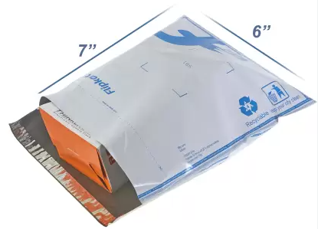

But after banning the polybag and also its harmful for the environment, Flipcart choose the sustainable packaging initiative including easy to recycle and easy to open like in this picture . 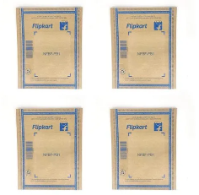

Also flipkart add some of the rules while packaging of the product

- Flipkart utilizes standardized packaging materials like cardboard boxes and air-cushioned envelopes to pack items securely for shipping.

- The packaging is designed to protect the products from damage during transit, with additional padding or wrapping used for fragile items.

- Flipkart has centralized packaging facilities where orders are aggregated, packed, and then handed off to logistics partners for delivery.

#### **Problem 2: Reduced sell**

These are some of things flipkart has one to help sellers reduce return and increase sales

* **Clear product description >**

Sellers can reduce returns by providing essential details like specifications and usage instructions.

* **Realistic pricing >**

Sellers can consider market research and price recommendation tools to implement a realistic pricing strategy.

* **Quality check feature >**

Sellers can earn the Flipkart Assured badge to gain the trust of potential buyers. This badge can help build a loyal customer base and drive repeat purchases.

* **Transparent settlement process >**

Flipkart's settlement process can help sellers establish their business.

* **7 days- payments >**

Flipkart's 7-day payments can help sellers facilitate rapid capital rotation.

#### **Problem 2: Counterfeiting and Fraud products**

Problem = Fraud product undermine consumer trust and brand reputation , posing a significant challenge for online marketplace

Solution : Flipcart employs various strategies to combat fraud and ensure product authenticity .

**Removing infringing products -**

Flipkart has a process in place to remove products that infringe on intellectual property rights.

**Investigating and taking legal action -**

Flipkart has investigated cases and taken legal action against fraudsters and scammers.

**Strengthening systems and processes -**

Flipkart continuously works to improve its systems and processes to protect customer data.

**Educating customers -**

Flipkart provides information on how to spot fake websites and apps, and how to contact customer support.

**Encouraging reporting -**

Flipkart's Infringement Verification process allows intellectual property owners to report listings that infringe on their rights

Flipkart also provides a customer-care number if anyone sees any kind of fraudulent activity on this website then he/she can contact customer support at 1800 208 9898. Authorized Flipkart representatives will never ask for sensitive information like passwords, OTPs, or PINs.

#### **Problem 4: Return Fraud With Counterfeit Products**

**Problem** - Sometimes some of the customers exploit the return policy of Flipkart by purchasing the genuine branded products and swapping them with the counterfeit items , and returning the counterfeit goods for a refund , effectively obtained the authentic product for free while defrauding both Flipkart and the brand .

**Solution** - Flipkart employs various strategies to combat return fraud involving counterfeit products, including

* **Reporting fraud -** Customers can report suspected fraud to Flipkart by calling their toll-free customer care number at 1800 208 9898. Customers can also send a direct message to Flipkart Support on Twitter. When reporting fraud, customers should provide as many details as possible, including screenshots of suspicious messages and the phone number of the fraudster.
* **Flagging fake accounts -** Flipkart flags and reports fake accounts that impersonate Flipkart. Customers should only interact with the verified Flipkart Support Twitter handle.
* **Educating customers -** Flipkart educates customers on how to shop safely and avoid fraud. They also provide information on how to identify fake Flipkart websites and apps.
* **Open box delivery -** Flipkart offers open box delivery to safeguard customer interests.

#### **Problem 5: A high Competition with other e-commerce website**

**Problem** - As we know at present there are many e-commerce websites we can see such as Amazon,Myntra ,and many more and Flipkart is an Indian company . An e-commerce website needs all the new functionality and new updates to maintain their place on the top .

Solution - Flipkart has a tough competition with amazon , and i think as a portal it has to give the best offer for gaining more customers and also can enhance its reach in the world . Here are some following topics which can be useful for maintaining and increasing the customer efficiency for flipkart.

* **By applying offers**

Flipkart is an Indian company and in India there is an environment of opportunities . So Flipkart can active some of specific sell’s belong to specific occasions this can be useful for attract customers towards to the website .

* **By detail the product**

Normally customers want to get to know about the product in detail . and flipkart fulfilled this condition very gracefully . This is profitable when a customer is not satisfied with the product and wants to know more about the product .

* **By make easy to purchase**

Flipkart provides an easy to purchase option , also provides the loan authority which can be useful to customers that he do not need to go anywhere on other platforms when he/she can do multi tasks here only on one platform .

* **By suggestions**

Many customers prefer some of the options while purchasing a product . Flipcart fulfills this condition very gracefully .It gives you many suggestions with similar products and within the same range too . where customer can easy to choose the right one according to the need

* **By using AI**

At present approx all of the website use Ai for make the site little bit more interesting and Flipcart is also count on these kind of websites ,it provides a AI Where user can use it according to its need , also provide chatting AI where customer can take the information about their product ,and this is so much help full to track orders or we can say to know about the order.

* **By customer satisfaction and best review**

Flipkart provides a wide range of review systems where customers can share his/her experience about the product and the satisfaction . And it is useful for genuin sellers and genuine customers also . If a seller gets the best review then automatically his/her popularity will be increased and if a customer buys a product he/she can judge the product by seeing reviews about the product so it is totally worth it .

#### **Conclusion:**

In summary, Flipkart has established itself as a major player in the Indian e-commerce market by addressing various real-world problems and continuously innovating. The company's approach to solving issues like accessibility, convenience, and price transparency has significantly enhanced the online shopping experience for its customers. By focusing on small business empowerment and logistic efficiency, Flipkart has also contributed to economic growth and supported entrepreneurship.

### **Top Features of Flipkart :**

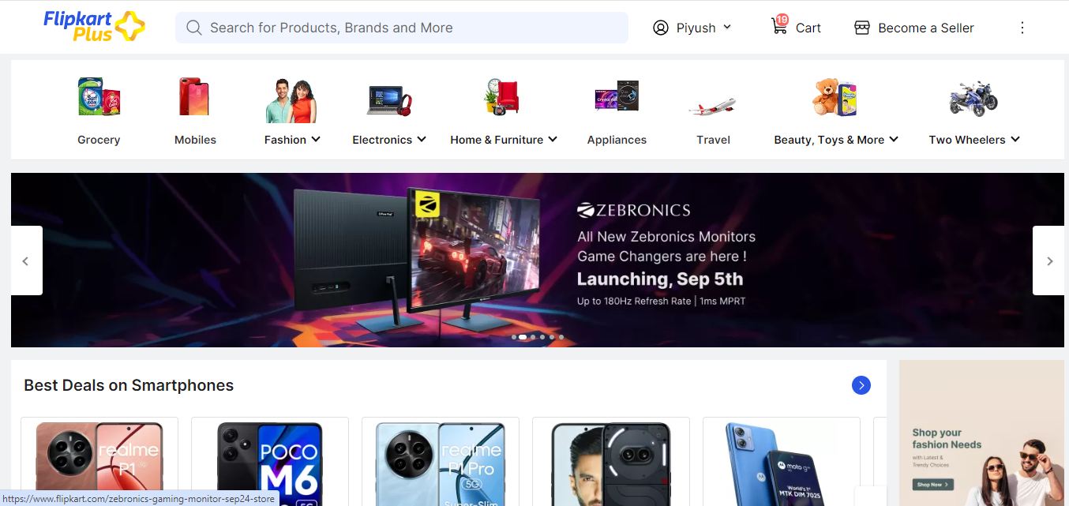

This is the dashboard of this site where we can see many of the features lets talk about some of specific features.

1. **Wide product selection :-** Variety: Flipkart offers a vast array of products across multiple categories, including electronics, fashion, home appliances, books, and more. This extensive selection ensures that customers can find virtually anything they need in one place.
2. **User-Friendly Interface:**-The website and mobile app are designed to be intuitive and easy to navigate. Users can easily search for products, filter results, and view detailed product information.

Flipkart provides personalized recommendations based on browsing history and purchase behavior, helping users discover products relevant to their interests.

1. **One-Click Purchasing:-** The one-click purchasing option streamlines the checkout process, allowing users to buy products quickly without having to re-enter payment and shipping information.
2. **Fast and Reliable Delivery: -** Flipkart offers various shipping options, including expedited delivery for premium members. The platform’s logistics network ensures timely and reliable delivery, even in remote areas.

In select locations, Flipkart provides same-day or next-day delivery for certain products, enhancing convenience for urgent purchases

1. **Easy Returns and Exchanges:-** Flipkart has a user-friendly return and exchange policy that allows customers to return products within a specified period if they are not satisfied.

In many locations, Flipkart offers return pickup services, making it easier for customers to return items without additional effort.

1. **Secure Payment Options:-** Flipkart supports a range of payment options, including credit/debit cards, net banking, digital wallets, and cash on delivery (COD).

The platform uses advanced encryption and security measures to protect users' payment and personal information.

1. **Discounts and Offers:-**  Flipkart frequently offers various discounts, deals, and promotional offers, including seasonal sales, festive discounts, and flash sales.

Users can apply coupon codes for additional savings and earn cashback on certain purchases, enhancing the overall value of their shopping experience.

1. **Customer Reviews and Ratings :-** Customers can read reviews and view ratings for products, helping them make informed purchasing decisions based on the experiences of other buyers.

Flipkart provides ratings and feedback for sellers, which aids in evaluating the credibility and quality of the products being purchased.

1. **Flipkart Assured :-** The Flipkart Assured badge signifies that products meet specific quality and reliability standards, providing customers with added confidence in their purchases.

Products with the Flipkart Assured badge often benefit from faster delivery and priority processing.

1. **Flipkart First :-** Flipkart First is a premium membership program that offers benefits such as early access to sales, faster delivery, and exclusive offers for members.

Members receive priority customer support and other exclusive services.

1. **Customer Support: -** Flipkart provides various customer support channels, including a dedicated helpline, email support, and live chat, to assist users with their queries and issues.

The platform also offers a comprehensive FAQ section and self-service tools for managing orders, returns, and other account-related matters.

1. **AI-Powered Search and Recommendations: -** Flipkart utilizes artificial intelligence to enhance search functionality, providing relevant results based on user queries and preferences.

AI algorithms offer personalized product recommendations based on user behavior and preferences, improving the shopping experience.

### **Schema Description:** The schema for flipkart involves multiple entities that represent different aspects of the platform. These entities include user_entity, product_entity ,seller_entity ,order_entity , review_entity and more. Each entity has specific attributes that describe its properties and relationships with other entities.

1. **User_entity**

* **User_id -** unique identifier for every user
* **User_name -** user’s chosen name or handle
* **Email -** user’s email-address
* **PasswordHash -** Encrypted password for authentication
* **Phone_number -** User’s contact number.
* **Address -** Array of user addresses (shipping, billing).
* **Order_history -**  Reference to the user's past orders.
* **Wishlist -**  List of products the user has saved for future purchases.
* **Cart -** Current items in the user’s shopping cart.
* **Loyalty_program -** Details of user’s participation in loyalty programs (e.g., Flipkart First).

1. **Product_entity**

* **Product_id -** Unique identifier for each product.
* **Product_name** -Name of the product
* **Category -**Category to which the product belongs (e.g., Electronics, Fashion).
* **Subcategory -**Specific sub-category within the main category
* **Brand -** Brand or manufacturer of the product.
* **Price** -Product price.
* **Discount -**Any applicable discount or offer.
* **Stock_quantity -**Quantity of the product available in inventory.
* **Description -** Detailed description of the product
* **Specification -** Product specifications (e.g., size, color, features).
* **Images -**Array of images of the product
* **Review -**Array of customer reviews and ratings.
* **Seller_id -** Reference to the seller of the product**.**

1. **Saleer_entity**

* **Seller_id** -Unique identifier for each seller.
* **Seller_name** -Name of the seller or store.
* **Contact_info** -Seller’s contact information.
* **Ratings** -Average rating given to the seller.
* **Product_list** -List of products listed by the seller
* **Sales_history**- Records of sales transactions and performance.

1. **Order_entity**

* **Order_id** -Unique identifier for each order.
* **User_id** -Reference to the user who placed the order.
* **Order_date** -Date when the order was placed.
* **Shipping_address** -Address where the order is to be shipped.
* **Billing_address** -Address for billing purposes
* **Order_status** -Current status of the order (e.g., Processing, Shipped, Delivered)
* **Payment_method** - Method used for payment (e.g., Credit Card, COD).
* **Payment_status** -Status of payment (e.g., Paid, Pending)
* **Products** - Array of products included in the order
* **Total_amount** - Total amount of the order, including taxes and shipping

1. **Review_entity**

* **Review_id** -Unique identifier for each review.
* **Product_id** -Reference to the product being reviewed.
* **User_id** -Reference to the user who wrote the review
* **Rating** -Rating given by the user (e.g., 1-5 stars)
* **Comment** -Textual feedback provided by the user.
* **Review_date** -: Date when the review was submitted.

1. **Cart_entity**

* **CartID:** Unique identifier for the cart**.**
* **UserID:** Reference to the user’s cart.
* **Products:** Array of products currently in the cart, including quantity.
* **TotalPrice:** Total price of items in the cart.
* **DateCreated:** Date when the cart was created.

1. **Address_entity**

* **AddressID:** Unique identifier for each address.
* **UserID:** Reference to the user’s address**.**
* **AddressLine1:** First line of the address.
* **AddressLine2:** Second line of the address (if applicable).
* **City:** City of the address.
* **State:** State of the address.
* **ZipCode:** Postal code of the address**.**
* **Country:** Country of the address.
* **AddressType:** Type of address (e.g., Shipping, Billing).

1. **Payment_entity**

* **PaymentID:** Unique identifier for each payment transaction.
* **OrderID:** Reference to the associated order.
* **PaymentMethod:** Payment method used (e.g., Credit Card, Digital Wallet).
* **Amount:** Amount paid.
* **PaymentDate:** Date when payment was made.
* **PaymentStatus:** Status of the payment (e.g., Successful, Failed).

1. **Logistics_entity**

* **LogisticsID:** Unique identifier for logistics records.
* **OrderID:** Reference to the associated order.
* **ShippingCarrier:** Carrier responsible for shipping (e.g., FedEx, DHL).
* **TrackingNumber:** Tracking number provided by the carrier.
* **EstimatedDeliveryDate:** Estimated date of delivery.
* **ActualDeliveryDate:** Actual date of delivery.
* **DeliveryStatus:** Current status of the delivery (e.g., In Transit, Delivered).

**ER Diagram:**

Let's construct an ER diagram that vividly portrays the relationships and attributes of the entities within the Flipkart schema. This ER diagram will serve as a visual representation, shedding light on the pivotal components of Flipcart’s data model. By employing this diagram, you'll gain a clearer grasp of the intricate interactions and connections that define the platform's dynamics. Here we can see the relationship between the attributes of these entities, how they connected with each other , and can have a little idea about how the things are dependent with each other .

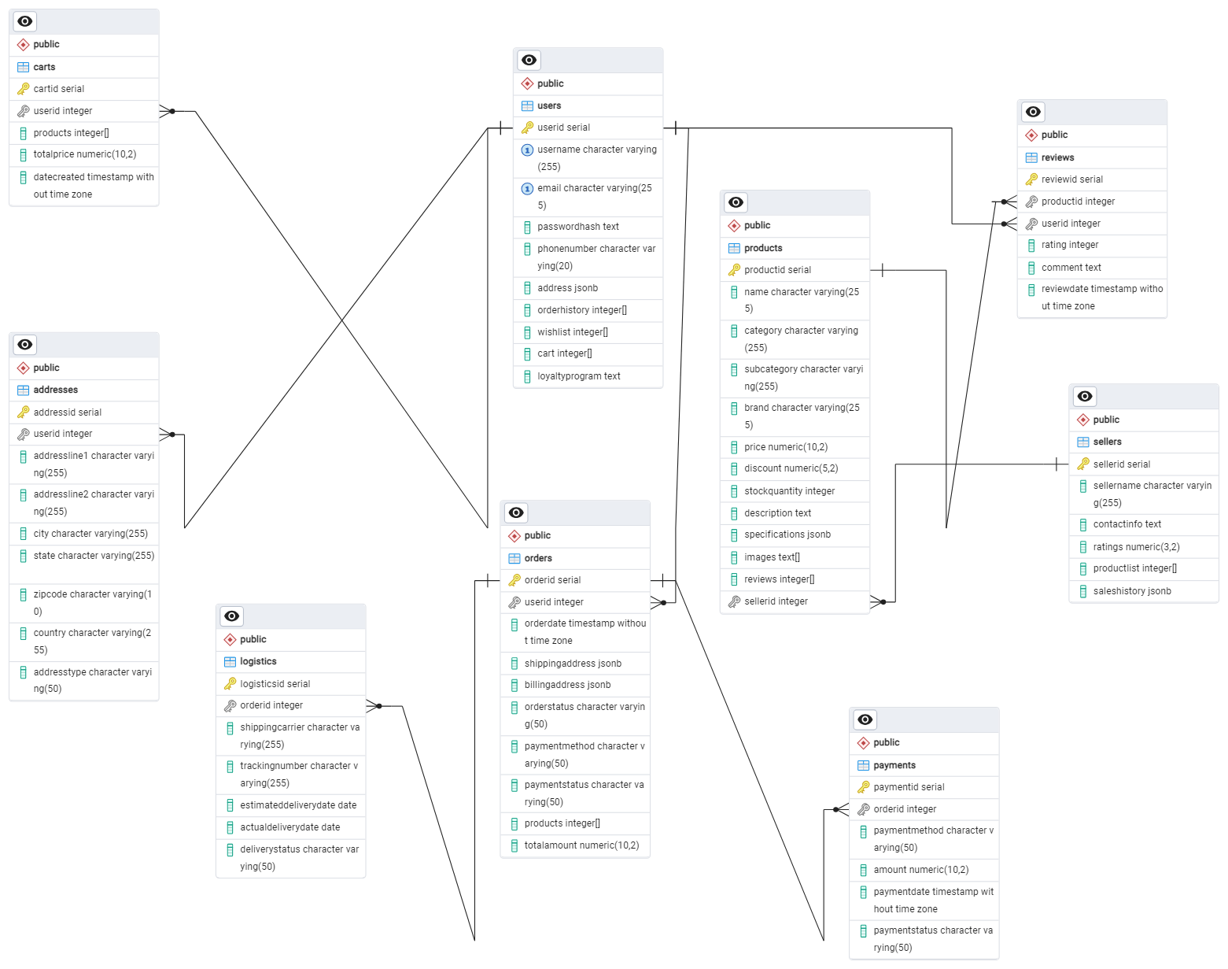

### **Conclusion**

In this case study we delved into the design of flipkart schema and entity-relationship diagram. Flipkart involves customers while they have to do shopping for any kind of specific product . Flipkart creates a bond with the customers and the sellers in a specific way by playing the role of a third party . It contains loyalty with sellers and customers both . It provides a platform where small businessmen can earn by selling their product . It is maintaining the trust of customers in a certain way where it is also handling the fake products and fake customers . It contains its reliability very well .